Task 1 Output:

Job Start Time: 23:43:39

Reading training data started at: 23:43:39
Reading training data ended at: 23:45:41

Training started at: 23:45:41
Training ended at: 00:26:13

Reading testing data started at: 00:26:13
Reading testing data ended at: 00:26:15

Testing started at: 00:26:15
F1 score: 99.6 %
Testing ended at: 01:32:31

Job End Time: 01:32:31

Elapsed time: 1 hr 52 min

Spark History:

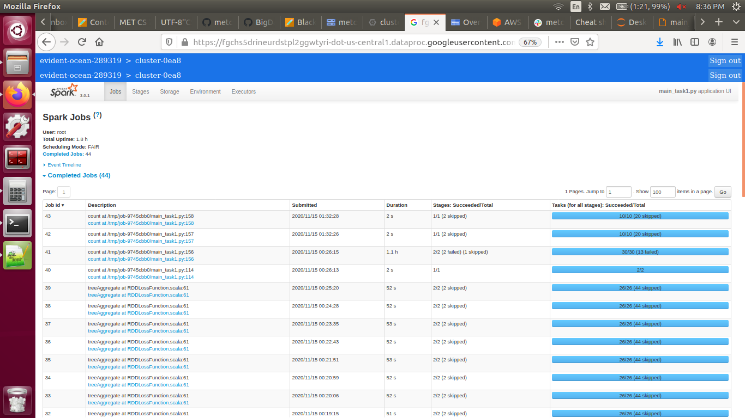

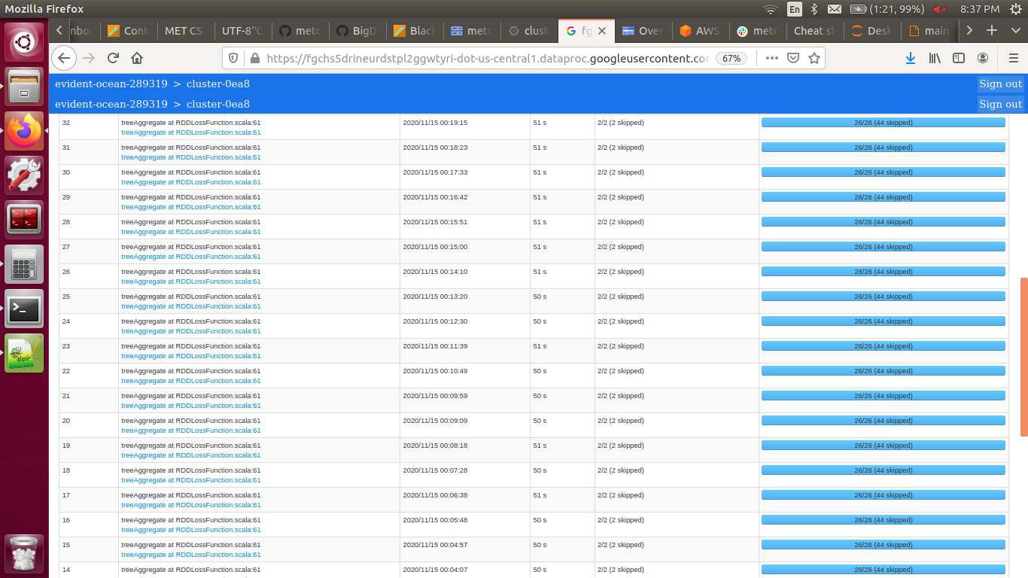

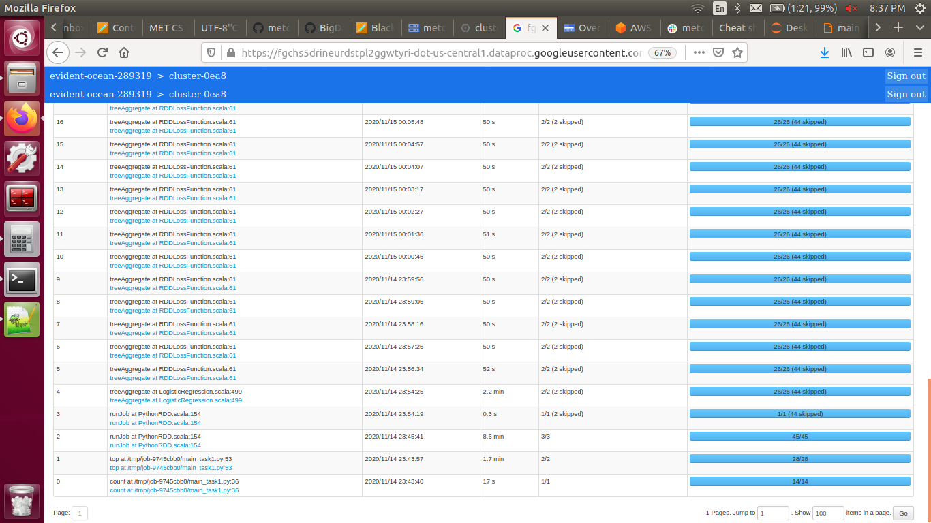

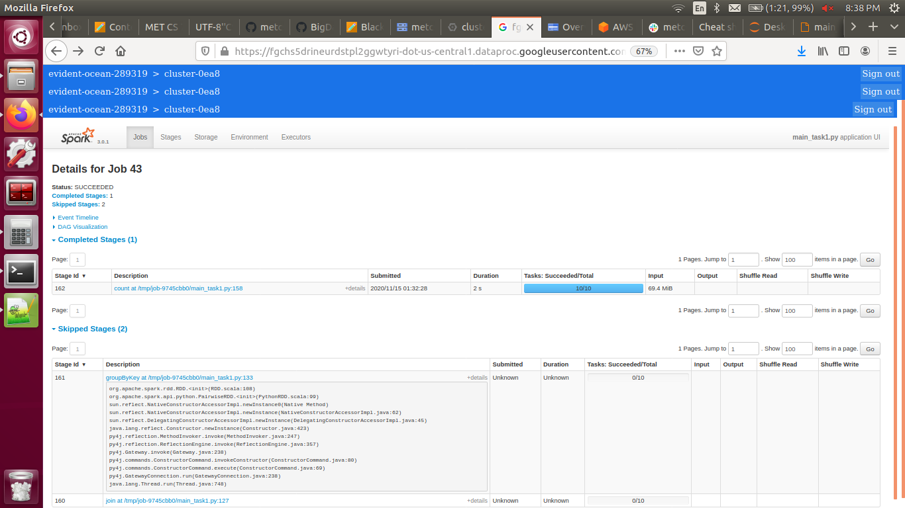

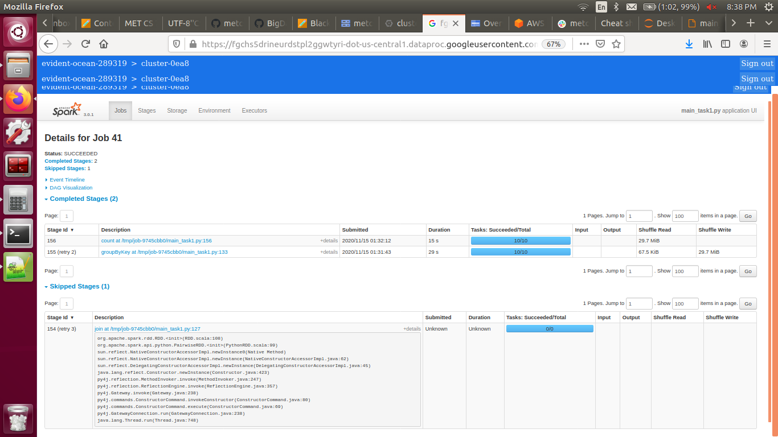

Task 2 Output:

Job Start Time: 03:49:52

Reading training data started at: 03:49:52
Reading training data ended at: 03:51:04

Training started at: 03:51:04
Cost stopped decreasing at: 415
Training ended at: 05:10:55

Reading testing data started at: 05:10:55
Reading testing data ended at: 05:10:57

Testing started at: 05:10:57
F1 score: 98.54 %
Testing ended at: 05:12:43

Job End Time: 05:12:43

Elapsed time: 1 hr 23 min

Spark History:

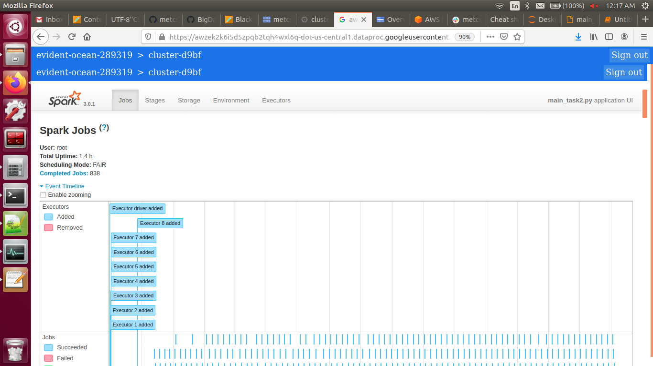

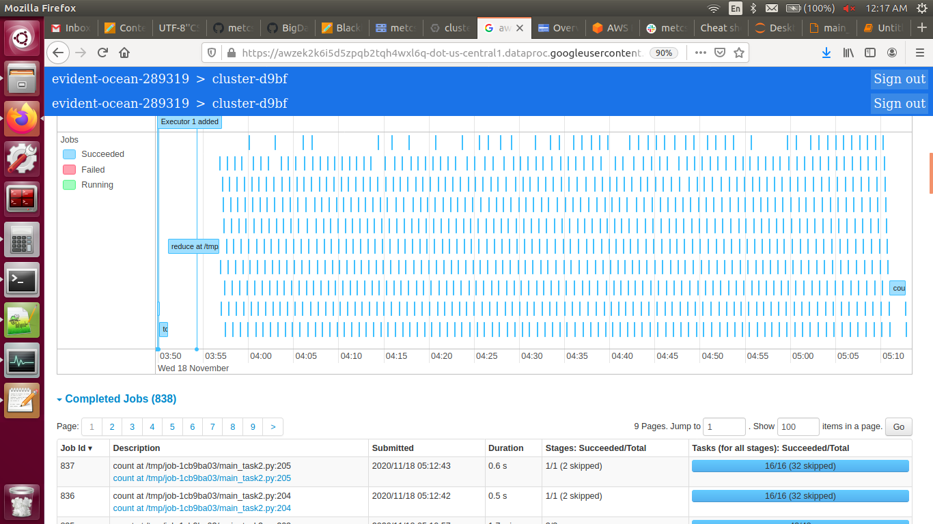

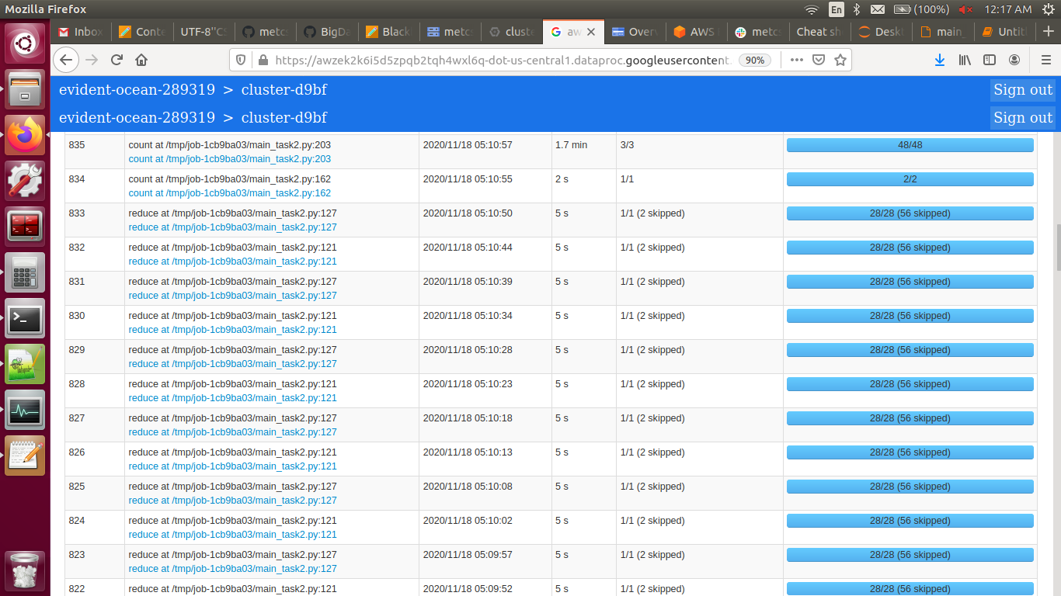

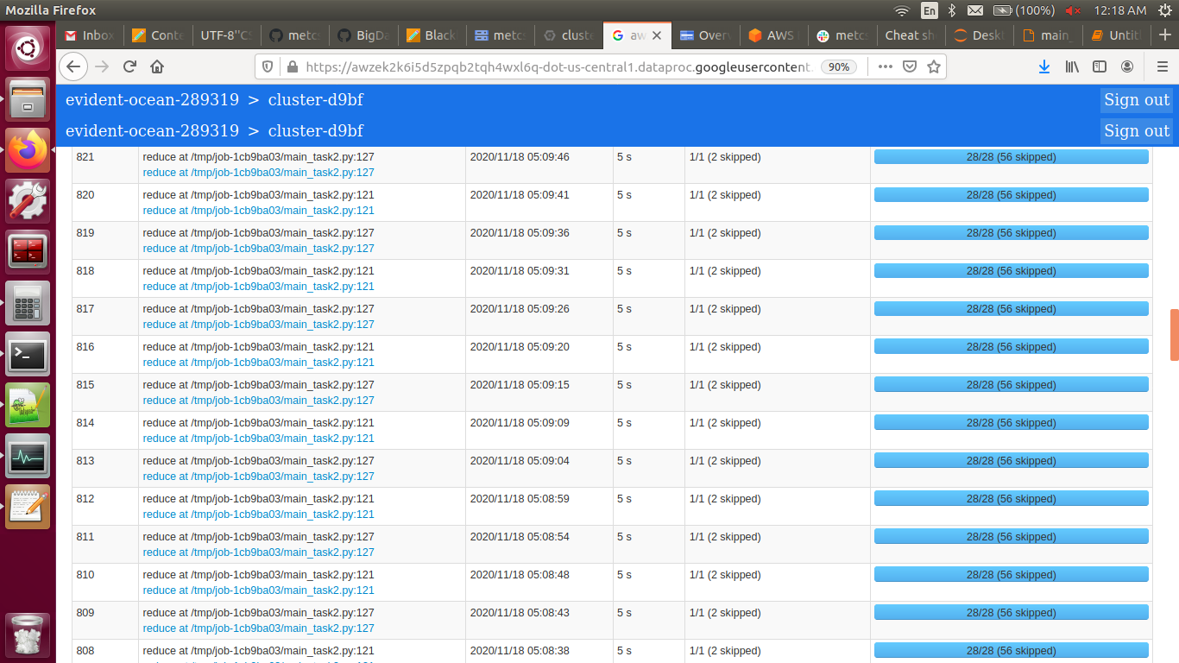

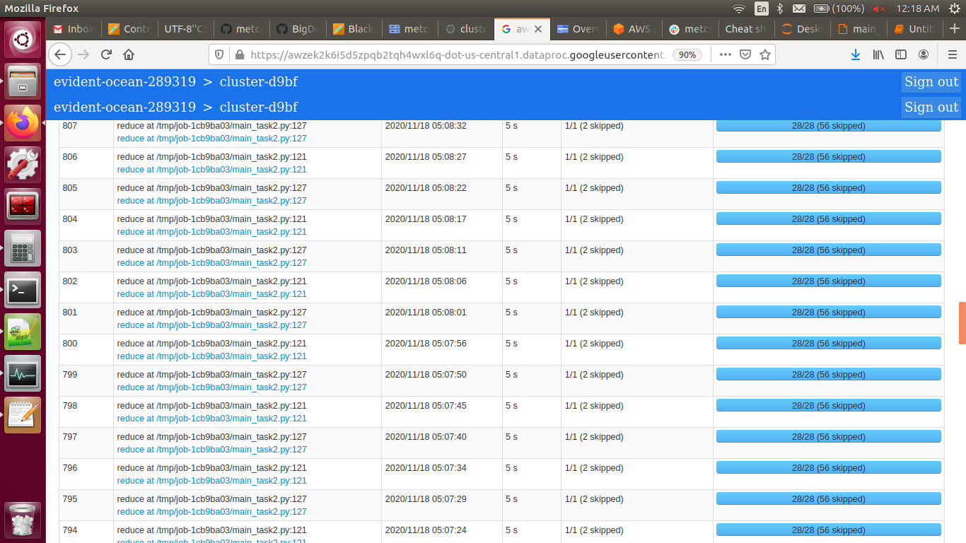

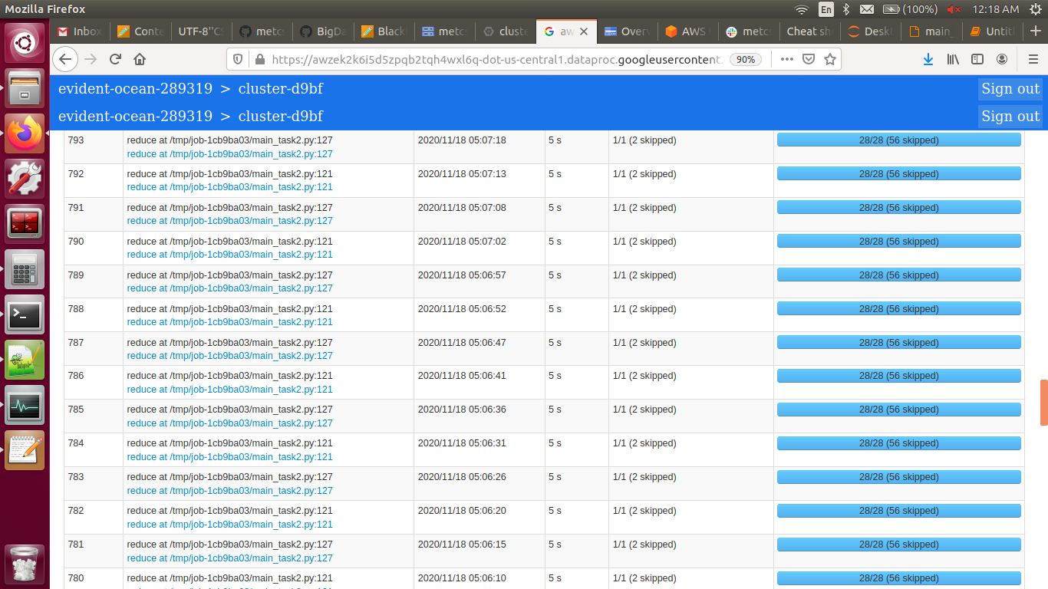

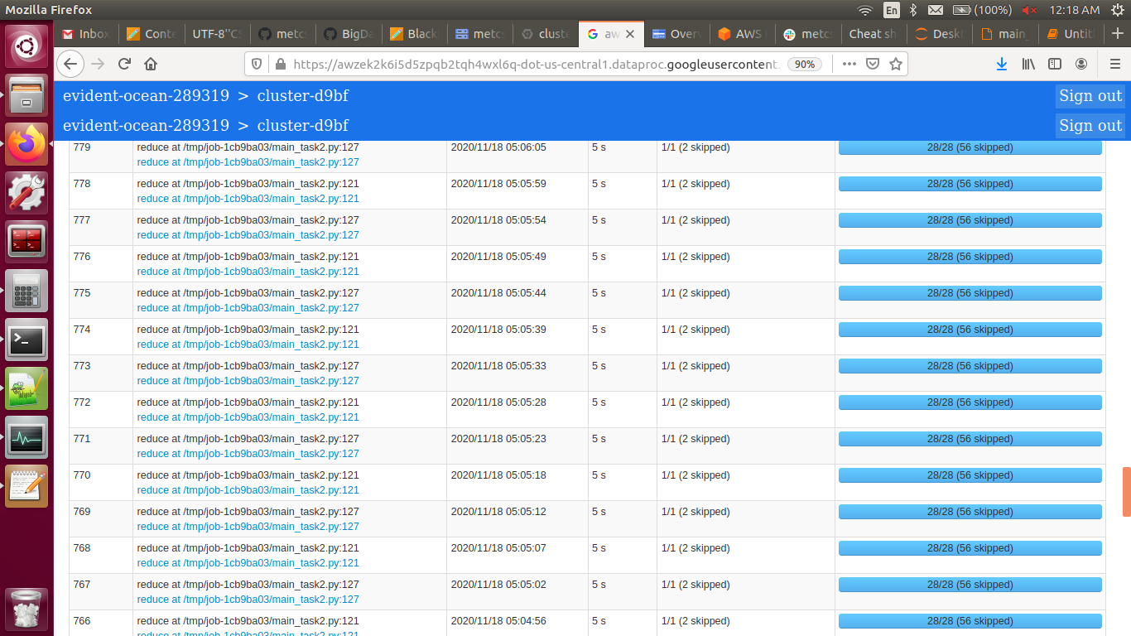

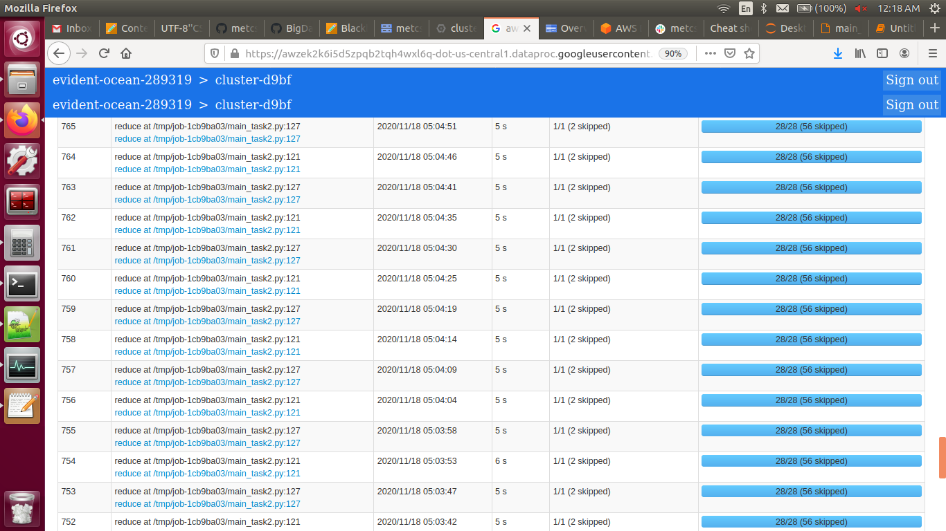

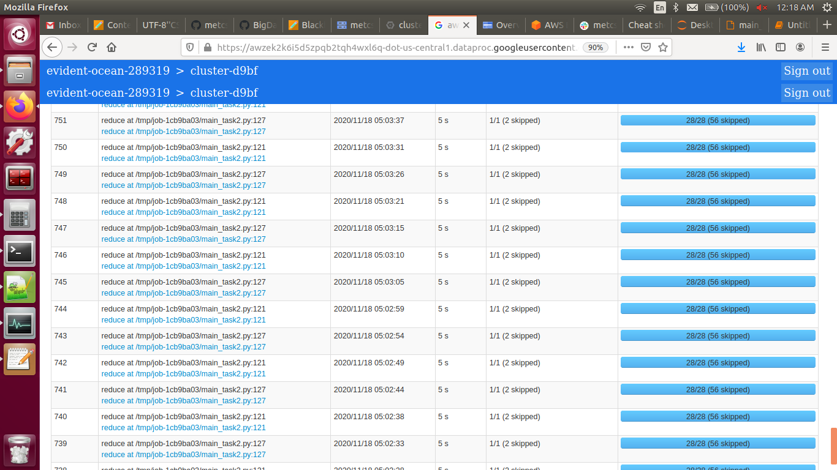
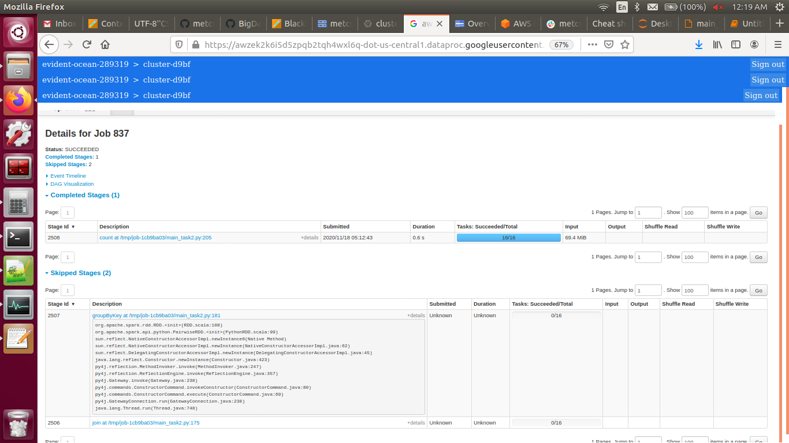

Task 3 Output:

Job Start Time: 14:30:28

Reading training data started at: 14:30:28
Reading training data ended at: 14:31:53

Training started at: 14:31:53
Cost stopped decreasing at: 1477
Training ended at: 19:12:34

Reading testing data started at: 19:12:34
Reading testing data ended at: 19:12:37

Testing started at: 19:12:37
F1 score: 95.75 %
Testing ended at: 19:14:27

Job End Time: 19:14:27

Elapsed time: 4 hr 47 min

Spark History:



